Enhancing Professionalism

Tips on Giving Feedback

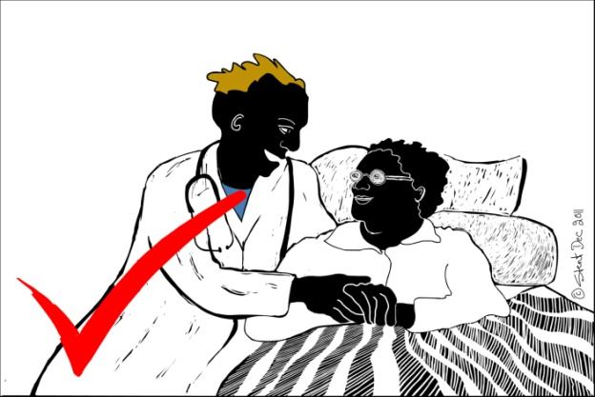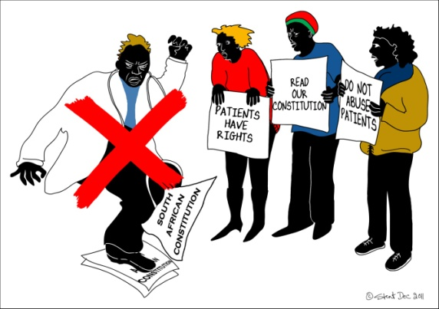

Ask for permission to give feedback
Do not pronounce judgments
Provide examples of observable behaviour
Avoid stereotypes and gender-based criticism
Be aware of your non-verbal language: quite often, non-verbal actions speak louder than words

Be specific | Statements such as "When you said this, I..." or "Your decision to withhold analgaesics..." focus on the particular action or statement. Avoid general comments such as "You keep..." or "You always...".
Challenge the idea or action, not the person | It doesn't help to draw attention to the pitch of someone's voice. Focus on actions or behaviours that a person can modify (if they agree this would be useful).
Talk in the first person | Statements such as "I felt ... " or "The patient seemed to ..." communicate personal responsibility for responses.
Ask questions to clarify or probe reasons | Questions such as "What did you take into account when you decided...?" or "What did you mean when you said ...?" credits the person with selection and judgment. The questions also help avoid criticisms and suggestions that are irrelevant to what the person is trying to do.
Identify the bridges | When you are giving critical feedback to a person, remind her or him of what you have in common. Comments such as "I know that when we do X we tend to...". Remind the person that you're on the same side. Sometimes a part of this same bridge may be to acknowledge differences. For example, "As a man, my experience is a bit different, but...".
Wherever possible, make suggestions for alternative approaches | Questions such as "Have you considered...?" or "What would happen if we tried...?" open a range of possible different responses. The use of "we" suggests that the issue and its solution is of interest to the whole group. Encourage others to add to the generation of different options. This will make it clear that there is not just one other (and therefore better) way to do it.
Don't assume that a difference is political | Check to see whether a conflict is based on different experience, different social identity, or a different role in the organization. The response may clarify the extent to which debate may change a person's view or behaviour.

